**BRAC UNIVERSITY**

**Department of Computer Science and Engineering**

|  |  |
| --- | --- |
| Examination: Quiz  Duration: 15 minutes | Semester: Summer 2023  Full Marks: 10 |

CSE 422: Artificial Intelligence

Answer the given question

|  |  |  |
| --- | --- | --- |
| Name: | ID: | Section: |

**Question 1**

You have been given a dataset containing 8 rows and four features (“unique_id”, “colour”, “size”, and “tail_length”). Each row represents a rat, and you are interested in finding the value of the label “has_disease”. Your goal is to build a decision tree from the table below:

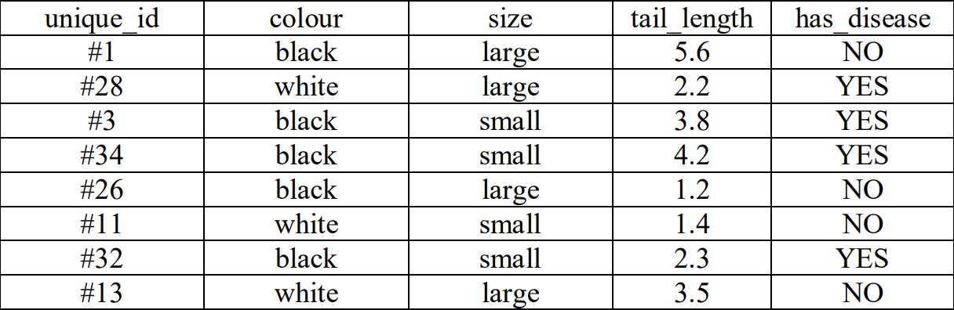

Suppose tail_length > 3 is considered large, and else considered small. Now, considering Color as the root node, find out the better feature between size and tail_length? Why? Show full calculation